**Appendix A**

HOUSING REVENUE ACCOUNT(HRA)

**Building our approach to strategic asset management**

**Our HRA *Asset Management Plan and Actions 2025 - 2028***

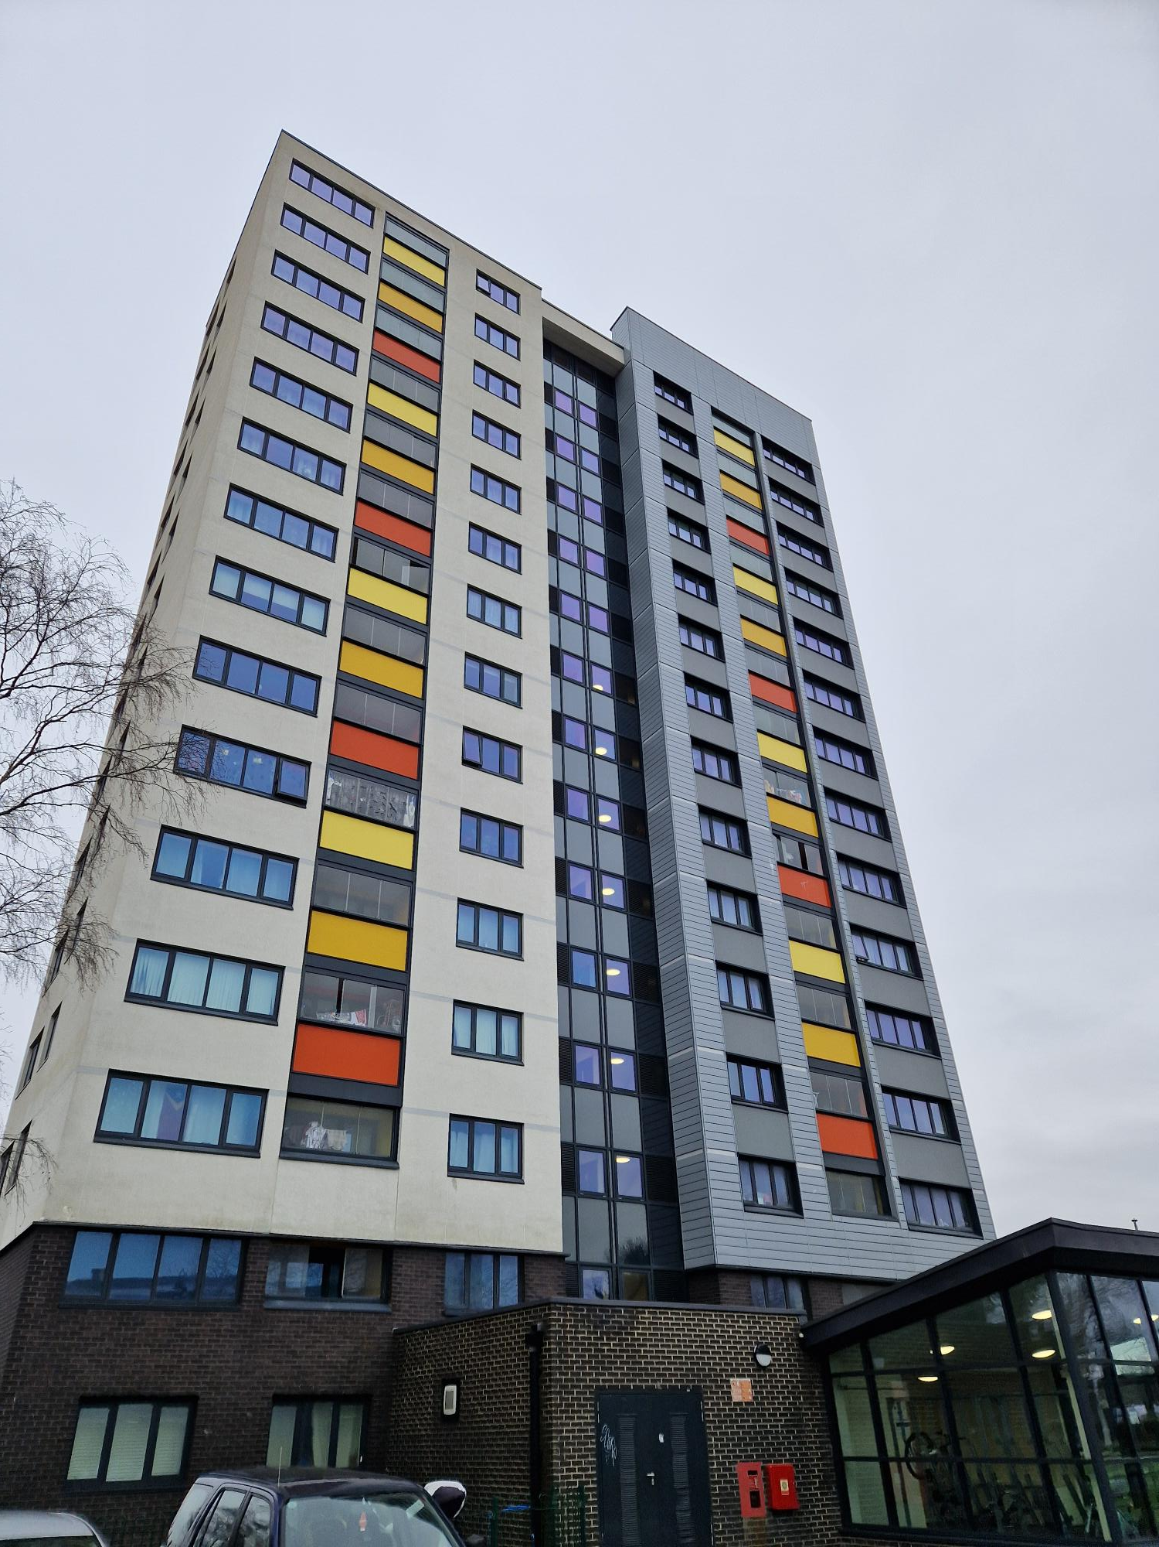 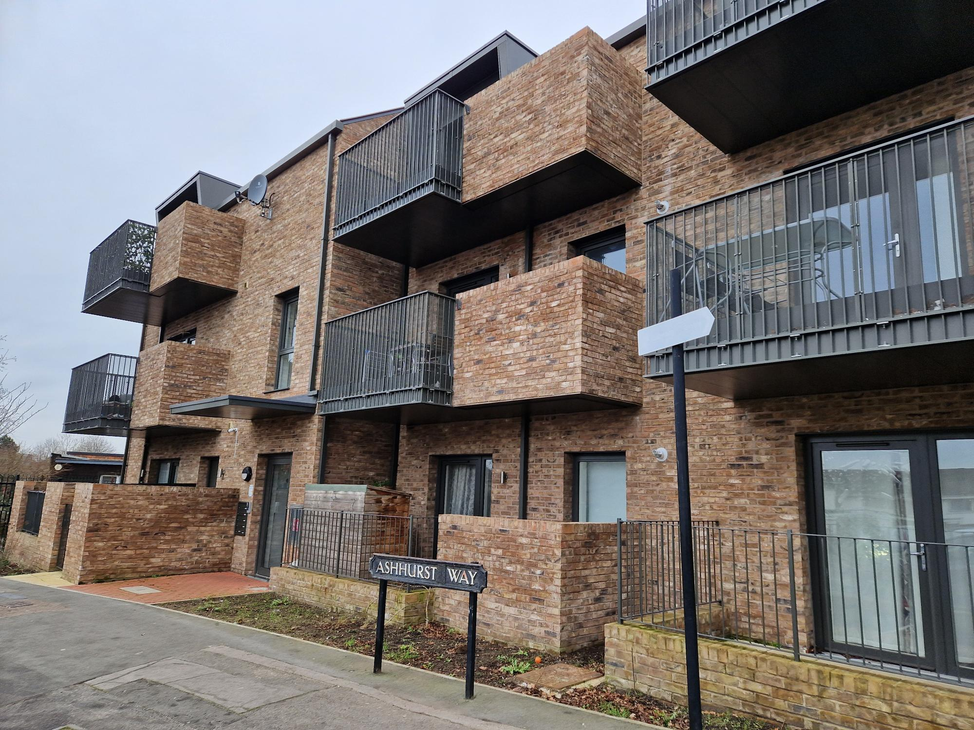 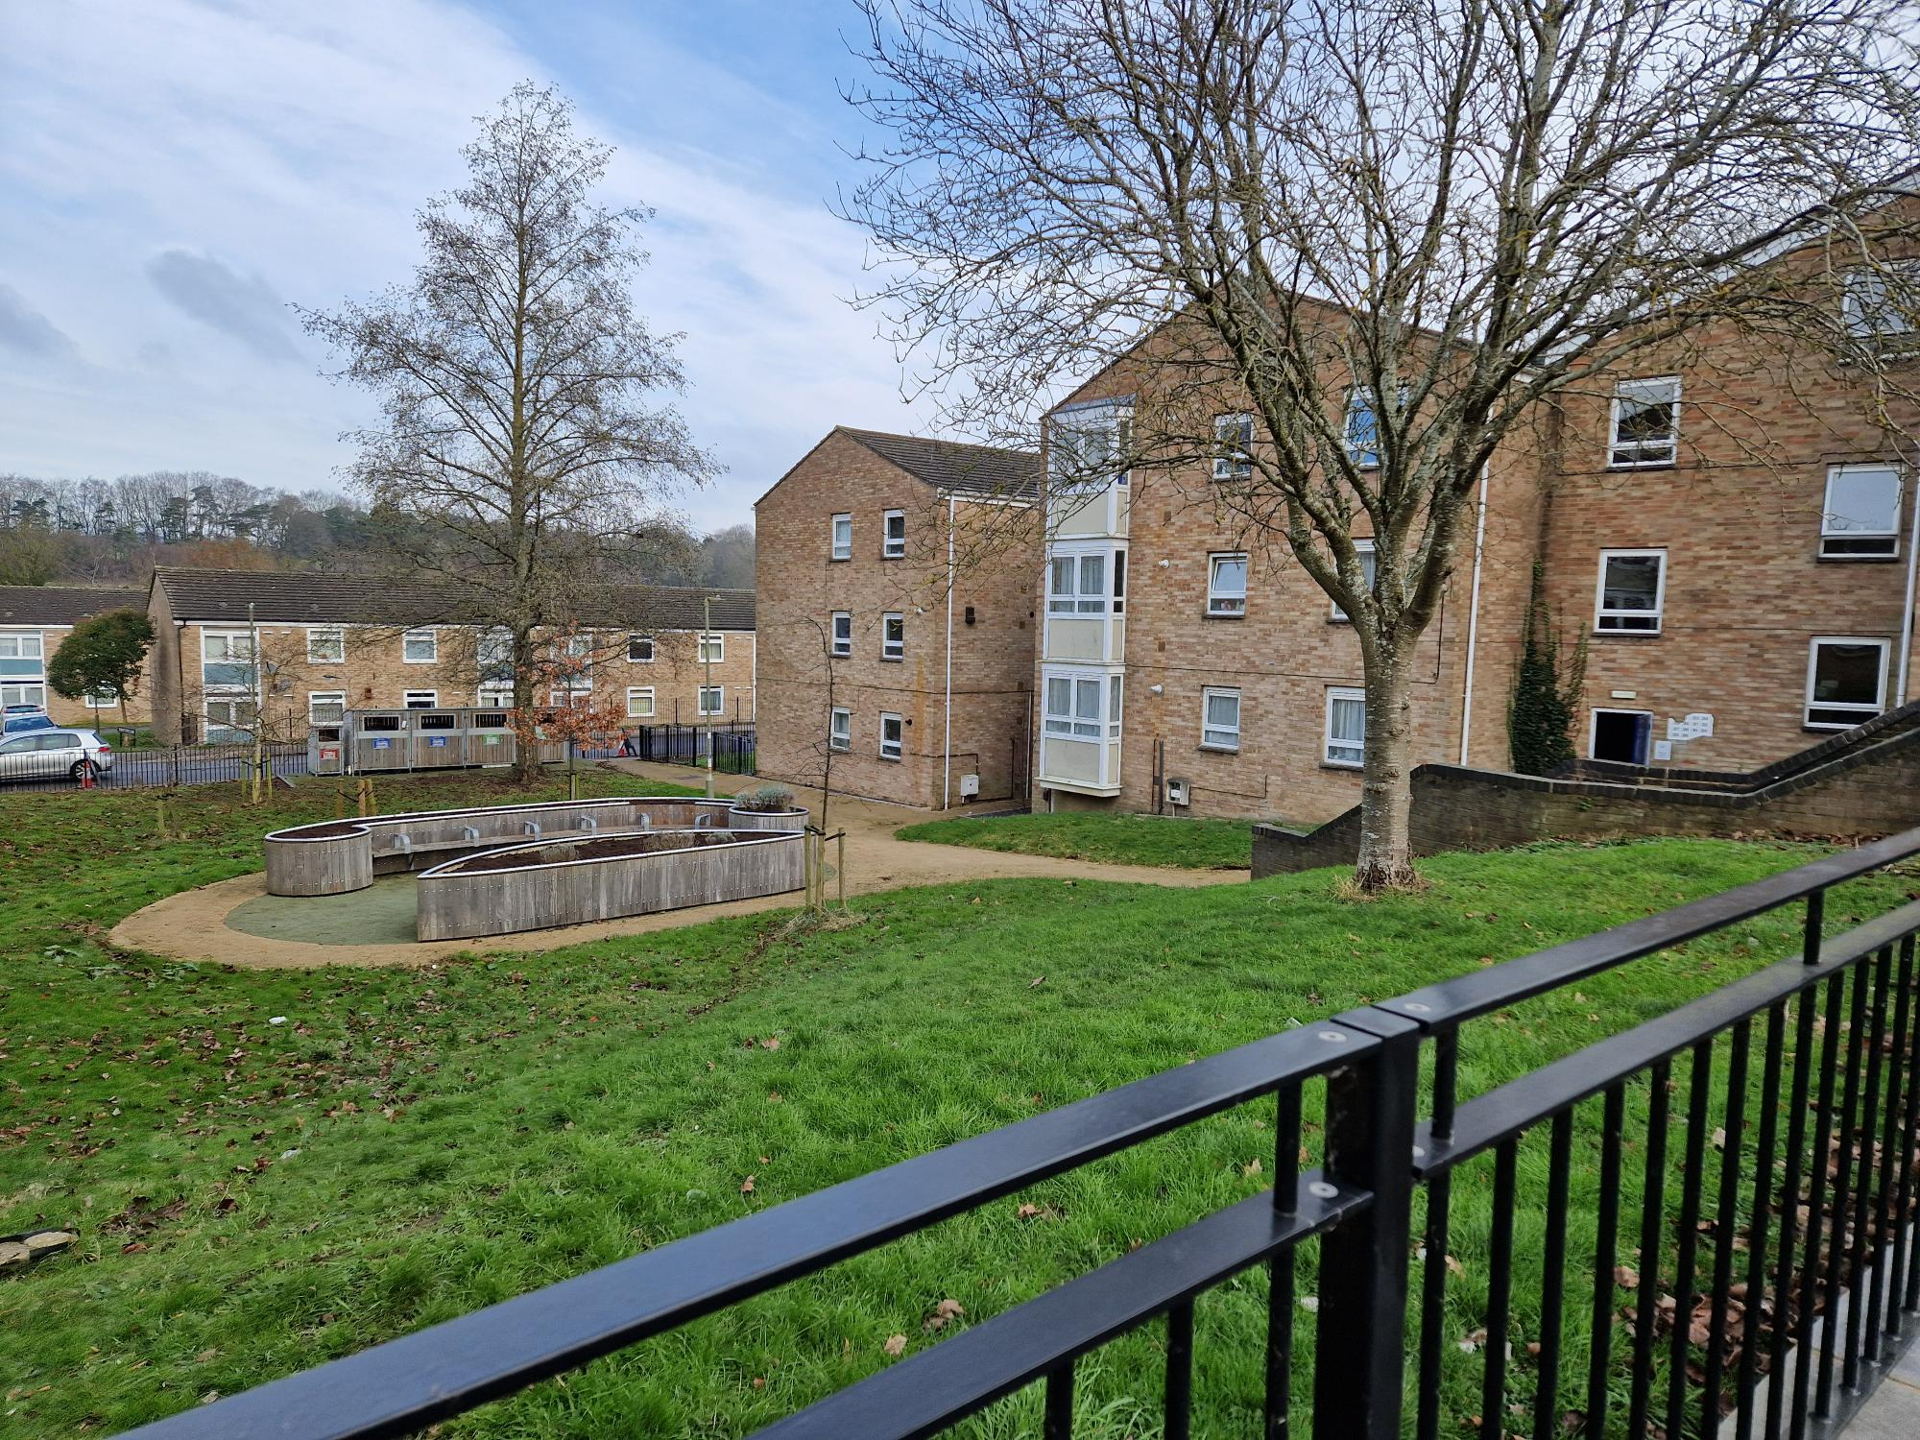

Our Asset Management Strategy (AMS) sets out how over the next three years the Council will work towards our vision – to be**“*a high-performing landlord, providing good quality homes and services that support thriving places and communities”****.*

The Plan is focused on the next three years and lays the foundations for the development of a longer-term Asset Management Strategy. This reflects the pace of change in the sector and the need for a ‘step change’ in our approach as we embed the 'building blocks' of strategic asset management.

Through the AMS, we will seek improvements in how we govern the decisions we make and the actions we need to deliver to ensure strong leadership and delivery of our asset management work. The AMS includes how we will listen and engage with tenants, deliver homes that are safe and in good repair, make decisions and use data to ensure we invest wisely to deliver homes that are ‘fit for the future’, and provide neighbourhoods where people want to live, work and play. The Plan sets out how all our work will be adequately resourced, with strong governance, and how we will account for our progress.

**Our HRA Asset Management Strategy**

**Contents**

**Executive Summary**

1. **Introduction**
2. **What are our drivers for change?**
3. **How do we currently stand on our approach to strategic asset management?**
4. **Asset management requirements and risk assessment**
5. **Putting in place an agenda for change – our Asset Management Plan**

**Action Plan**

**Executive Summary**

Our Housing Revenue Account (HRA) Asset Management Strategy sets out how we will have in place a range of well-planned strategic and operational asset management practices that are informed by the range of national drivers for asset management for social housing providers, within our local Oxford context. It represents a ‘step-change’ in our approach, to one where planned works programmes are made based on reliable up to date data, led and underpinned by a stronger approach to governance and decision making. The strategy links with other key strategic documents including the Council’s Corporate Plan and HRA Business Plan, forming a clear, joined up approach to looking after and investing in the HRA assets. The Strategy runs for three years and is designed to lay the foundations for a fully developed Asset Management Strategy from 2028.

The Strategy covers all repair and maintenance activities, including keeping homes safe, updating, improving, and investing in homes and estates so we provide good quality accommodation where people want to live. It also includes future facing issues such as energy efficiency works, and modernising and regenerating homes and estates, with a focus on the evolving needs of residents.

The Strategy is built around a suite of six priority actions. These address the key challenges we face:

* Responding to increasing levels of regulation to ensure homes are safe and well maintained.
* Providing homes for a net zero carbon future.
* The need to strengthen the tenant voice in decision-making.
* The need to maximise the resources of the HRA for investing wisely in the existing homes, whilst also funding much needed new additional homes.
* Ensuring systems and processes, policies, procedures and structures support efficient and effective service delivery, with good procurement and contact management used to deliver better quality services at a lower cost.
* The need to provide well-managed and well-maintained estates, with good quality green space, external and internal communal areas.

By building the governance and foundations for effective asset management, we will manage and minimise the risk implications for the Council, tenants and others of not managing homes effectively, helping us meet the regulatory requirements set out in the published Consumer Standards for social housing landlords.

**SUMMARY OF OUR HEADLINE ACTIONS**

|  |  |
| --- | --- |
| 1. **Ensuring every voice matters**   We need to:   * Engage, listen and learn, acting on what people say. * Offer genuine involvement and input when making decisions, developing policies, and designing services. * Communicate in an open, honest and respectful way, listening and learning from tenants’ feedback and complaints. | 1. **Establishing the right governance arrangements for effective decision making**   We need to:   * Improve our governance, using quality data to make well-informed decisions on our future services and plans, with a clear strategic vision and delivery actions that have buy-in. * Fully understand the condition and performance of our homes so we invest wisely. |
| 1. **Providing great homes that are fit for the future**   We need to:   * We need to deliver a great repair service, tackling damp, mould and disrepair issues quickly, demonstrating and providing assurance that we are keeping homes safe and in good condition. * We need to look to the future when making decisions on future investment, so the quality of our homes improves. | 1. **Working towards a net zero carbon future**   We need to:   * Ensure all homes meet EPC Band C by 2030. * Plan for meeting the Council’s ambition for Oxford to be ‘net zero carbon’ city by 2040. * Invest carefully in retrofit measures, so resources are spent wisely, ensuring a ‘no regrets’ approach to investment. |
| 1. **Supporting thriving places and communities**   We need to:   * Work with residents and partners to create thriving places where people want to live, work and play. * Provide well-managed and well-maintained estates, with good quality green space, external and internal communal areas. | 1. **Delivering an efficient and well-run service**   We need to:   * Use resources carefully, driving continuous improvement by having efficient and effective systems and performance management. * Use good procurement and contact management at all stages to deliver better quality services at a lower cost. |

All our actions will be driven, reviewed, measured and monitored by a new HRA Asset Management Plan Delivery Group.

1. **Introduction**

**With increased regulatory requirements, operational delivery pressures, and financial constraints, the imperative for us to have a strong, forward-thinking approach to asset management has never been greater. To do this, we need to** **have in place a range of well-planned strategic and operational asset management practices. These need to be informed by the range of national drivers for asset management for social housing providers, as well as our local context.**

To help us improve the way we plan and deliver our range of asset management activities, we have developed our HRA Asset Management Plan. It incorporates a set of priorities and actions for our repair, maintenance and investment work for delivery over 2025 - 27. Linking with other key strategic documents including the Council’s Corporate Plan and HRA Business Plan, the Asset Management Plan forms an important plank of the Council’s joined up approach to providing direction and clarity on looking after and investing in its HRA assets.

**What is Strategic Asset Management?** **Why do we need an Asset Management Strategy?**

The term ‘Strategic Asset Management’ describes the range of activities we need in place to make best use of resources in maintaining and improving our homes. While asset management includes repairs and maintenance, it is about much more than this. It is about keeping homes safe, updating, improving, and investing in homes and estates so we provide good quality accommodation in places people want to live. It also includes future facing issues such as energy efficiency works, and modernising and regenerating our homes and estates, all with a focus on the evolving needs of residents.

Our Asset Management Strategy has been produced using a best practice approach to developing asset management strategies. It has been informed by a self-assessment of our current performance in delivering asset management, and an analysis of our current challenges. It sets out an analysis of where we need to improve our governance of asset management and our performance in delivering a set of key actions, with an assessment of the associated risks. It then sets out an agenda for change and a detailed Action Plan for bringing about the improvements needed in our asset management planning and delivery.

The purpose of our Asset Management Strategy is to drive forward the range of decisions and actions needed across all aspects of asset management over the period to 2027. To secure maximum success, the Plan incorporates – and needs to be supported by – appropriate governance arrangements. These will help ensure that we use the right information, data, and intelligence about the HRA assets to make the right decisions for their long-term future.

**What will our Asset Management Plan deliver?**

Our goal is for the strategy to secure the improvements needed in how we:

* Drive forward, lead, govern and account for all the Council’s HRA asset management activities.
* Maximise the use of quality data and our understanding of the performance and condition of the housing assets to make good, informed decisions for the HRA.
* Resource and organise the management of the HRA assets through a strong, strategic client function.
* Build our knowledge and levels of confidence in our future investment programmes, considering tenant involvement and feedback.
* Fulfills our landlord responsibilities and regulatory requirements effectively through a process of continuous improvement in our asset management planning and investment.

We have developed a suite of six priority actions that form the basis for the Asset Management Strategy. These focus on stronger governance, taking on board the tenants’ voice, using better data to make more informed decisions, and on better resourcing all our work. The priority actions are:

1. **Ensuring every voice matters.**
2. **Establishing the right governance arrangements for effective decision making.**
3. **Providing great homes that are fit for the future.**
4. **Working towards a net zero carbon future.**
5. **Supporting thriving places and communities.**
6. **Delivering an efficient and well-run service**
7. **What are our drivers for change?**

**Within the social housing sector, we face a period of rapid change that will fundamentally reshape what we do and how we need to deliver strategic asset management services. We must be ‘agile’, – responding quickly to changes in national standards and our tenant’s needs.**

|  |
| --- |
| **We own and manage almost 8,000 homes in the HRA with a mix of ages, types, and sizes.**  **We have an ageing stock of properties, with well over half being over 60 years old.** |

**Increasing levels of regulation to ensure homes are safe and well maintained**

Scrutiny of the social housing sector has focused attention on improving the safety, quality and sustainability of homes, with stronger governance and more accountability. We need to improve the quality of our data to ensure we invest wisely to address the significant investment needs of our city’s ‘ageing’ housing stock. It is essential we provide tenants with assurance that we are investing sufficiently so homes meet all safety, legal and regulatory compliance standards, quickly tackling damp, mould and disrepair issues that may arise.

**Providing homes for a net zero carbon future**

To tackle climate change, Oxford has set an ambition to be net zero carbon by 2040. There are also national targets for social landlords to ensure all homes have a minimum energy rating of EPC C by 2030. To meet the challenges of a net zero carbon future, we need to carry out significant and costly retrofit programmes for homes. This will also help address the ‘cost of living’ crisis that is seeing rising bills for all, improving the ‘affordability’ of living in homes.

**Strengthening the tenant voice**

Our tenants want us to listen to them, and act on what they say.

This is not only good practice - but the new regulatory Consumer Standards also require us to involve tenants and ensure their input into decisions about services, homes, and neighbourhoods. We must be open, honest, and respectful, listening and learning from tenants’ feedback and complaints and accounting to tenants for our performance, all to help ensure services are delivered in a tenant-focused way.

We have conducted an extensive consultation exercise to understand our tenants’ priorities, receiving over 550 responses giving us confidence that the results accurately reflect the views of residents. Tenants have told us that we need to focus on the basics - A circular chart with text
getting repairs done, keeping people safe in their home, investing in kitchens and bathrooms, as well as improving the energy efficiency of homes, and improving external areas.

**Resources and partnerships**

The Housing Revenue Account is under considerable pressure as we seek to deliver the much-needed new additional homes our city needs, while also maintaining and improving our existing homes. We need to invest wisely, drawing on data and intelligence on the ‘performance’ of our homes to ensure they are sustainable for the longer-term.

We need to work across the Council and with partners to ensure our systems and processes, policies, procedures and structures support efficient and effective service delivery. We must also employ the principles of good procurement and contact management at all stages to deliver better quality services at a lower cost.

**Supporting thriving communities and well-designed neighbourhoods**

The Council’s Thriving Communities Strategy puts a renewed emphasis on ‘place-making’ and the importance of neighbourhoods being safe and successful communities. Through our asset management work we need to play an important role in directing how we will provide well-managed and well-maintained estates, with good quality green space, external and internal communal areas.

1. **How do we currently stand on our approach to strategic asset management?**

Through a process of external review and self-assessment, we have evaluated how well our organisation is currently performing against ten key aspects of strategic asset management. Our leadership team, senior and operational managers all contributed to this wide-ranging and robust assessment.

|  |  |
| --- | --- |
| **Governance - leadership, vision & strategy**   * In response to new landlord obligations arising from the Social Housing Regulator – there are opportunities to ;   + strengthen governance arrangements across services.   + develop a more joined up vision and aspirations we have for our tenants and council’s responsibilities as a landlord – maintaining our focus on tenant safety and delivering best in class tenancy management services.   + Maximize our efforts to get better value for the money we spend on improving services and a better return to the Housing Revenue Account | **Partnership working**   * Whilst partnership working is strong, there are opportunities to develop greater openness, trust and honesty, to better agree shared goals and values and ensure better communication between our key service providers * We need to seize the opportunity the Commissioning Review presents for re-setting the ODS relationship and ensure better outcomes for tenants . * We need a shared partnership vision and goals that we all buy into and understand. |
| **Data driven works programmes**   * We are making improvements to data, but accessing it is difficult and need to work on removing barriers * We are building our stock condition survey data, but recognise this will take time to complete, we need to ensure QL can effectively hold the data. * Budgets need to be driven by up to date, accurate stock data, rather than by custom and practice. | **Safety & compliance**   * Recent regulatory involvement has brought compliance into focus, with policies, procedures and recording keeping all needing to be improved. * Systems need to allow easy and full visibility of compliance at any one time. * We need a clear understanding of outstanding remedial works in key compliance areas and works programmes in place to address these. |

|  |  |
| --- | --- |
| **High calibre & motivated staff**   * Staff turnover and good housing skill shortages across the profession is making it difficult to recruit the skills required * We need to improve our approach to induction, training and team development. * Our organisational culture needs building through a stronger operating framework and collaborative working | **Investment targeted to future needs**   * We need to take a stronger position on defining standards with reference to costs/benefits – for materials, works specifications, voids etc. * We need to complete the development of a new energy efficiency/retrofit strategy. * We need to develop and agree a longer-term, evidenced based plan for future investment |
| **Systems, processes & procedures**   * Our systems, processes and procedures need developing and their functionality improving. * We need to develop a clearer view on what we are trying to achieve and what good looks like. * We need a set of clear, transparent approaches to dealing with the range of key issues. | **Value for money**   * We need to ensure that we are making the best financial return for the HRA and value for money through our contracting. * The delegation of budgets to ODS presents real challenges which need to be addressed through a much stronger strategic client role. * The Commercial Review is a big opportunity for a reset on value for money with ODS and more widely. |
| **Performance & programme management**   * Our view on performance across the range of key asset areas isn’t sufficiently clear and we rely too heavily on third party data and reporting. * We need to ensure robust contract management and oversight of all contractors, including ODS. * We need to be a strong strategic client, taking ownership of the ODS relationship, taking a lead on budgets and specifying materials, components, specifications etc. | **Tenant-focused services**   * We are insufficiently open and transparent with tenants about services and standards * We need to develop our service standards * We need to develop a stronger focus on resident engagement with more resident groups, taking ownership to drive future programmes of work with them, building on the results of the tenant priorities survey in July 2024. |

1. **Building the governance and foundations for effective asset management**

We have built on our self-assessment to arrive at SIX key asset management requirements for building the governance and foundations for effective asset management. For each of these, we have sought to understand how our approaches need to address these, and the risk implications for the Council, tenants and others if we do not do so. Many of these risks relate to not being able to meet regulatory requirements set out in the published Consumer Standards, and they need to be managed through an effective governance and accountability framework.

1. **Tenant engagement and influence**

|  |  |
| --- | --- |
| **Asset Management Requirement** | **Risk Implications** |
| We need to fully understand tenants’ needs and expectations of our services and their improvement priorities. | If we do not fully understand the needs and expectations of tenants, then our works and services may fail to sufficiently meet their requirements. The Regulator of Social Housing (RSH) requires us to ensure tenants and residents can influence decision making and show how their views have been considered. |
| We need to use targets to drive improved levels of satisfaction with our services and the safety and repair of homes. | The setting of targets is a key performance management tool and helps tenants hold us to account. Without them, we will struggle to drive and measure improvements in the quality and reliability of our works and services and the levels of satisfaction with them. |
| We need use tenant feedback and complaints to help improve our repair and maintenance services. | If we do not do this, we will miss crucial opportunities to improve services. We will also fall short in meeting the requirements of the RSH that we learn from feedback and complaints. |
| Tenants and residents should help shape and inform service or home quality standards, investment programmes, and our works to decarbonise homes. | We will fall short of meeting the requirements of the RSH to ensure tenants and residents influence decision making. Also, that the delivery of repairs, maintenance and planned improvements to homes and communal areas is informed by the needs of tenants. |
| We need to communicate well with tenants and residents and keep them sufficiently well informed on things that matter to them. | To meet regulatory requirements, we must clearly communicate with tenants in a timely manner on a range of matters, including about repairs, maintenance and planned improvements to homes. |
| We need to maximise the use of IT and modern methods of communication to best meet tenant’s needs. | This is important to secure the efficiency and service delivery improvements that modern IT and methods can bring. |

1. **Establishing the right governance arrangements for effective decision making**

|  |  |
| --- | --- |
| **Asset Management Requirement** | **Risk implications** |
| We need to have clear strategic direction and leadership in place for making the key decisions needed for driving forward our HRA asset management work. | Without clarity of purpose, roles and behaviours, coupled with strong leadership, management and direction, our asset management work will lack focus, key decisions won’t be made. |
| We need to have an appropriate group/forum in place that can take ‘ownership’ of the delivery of our asset management work and priorities, with representation from across housing assets and related teams. | Without a dedicated group/forum for tracking, measuring and monitoring progress in delivering out asset management priorities, our work will lack focus, and necessary actions will ‘drift’. |
| We need to develop our IT systems, operational and management processes to meet the needs of our complex business and strengthen our service planning and control capabilities. | Good data on which we can rely is fundamental to good decision making. Good quality IT systems, data, systems and procedures, we will help us meet the regulatory requirement for using data to inform the provision of good quality, well maintained and safe homes. |
| We need to continue building on our stock condition data and put in a mechanism in place to use repairs data to inform our service planning or works. | Without fully up to date and complete stock condition data we will struggle to meet the regulatory requirement of having an accurate record at an individual property level of the condition of homes, based on an up-to-date physical assessment of all homes. |
| We need to proactively survey homes to find tenant safety or housing quality/condition issues based on an intelligence, data-led approach. | The RSH has made it clear that periodic stock condition surveys alone will not be sufficient and that intelligence-led, risk based ad hoc inspections are required to identify and pick up on potential hazards or disrepair issues. |
| We need to have a data-led rolling 5-year investment programme that sets out what and when improvements will be made to ensure safe, good quality homes that are ‘fit for the future’. | Our works programmes need to be sufficiently well-developed and targeted so we meet the regulatory requirement for keeping tenants advised on when works will be carried out on their home. |
| We need to fully understand the relative performance (strengths/weaknesses) of properties so we can make long-term investment decisions based on the sustainability of homes/schemes/estates. | It is a long-standing regulatory requirement that we understand the relative performance of our housing stock so we can make informed decisions on stock investment and ensure value for money. |

1. **Safe homes that are in good repair and meet current and future facing standards**

|  |  |
| --- | --- |
| **Asset Management Requirement** | **Risk implications** |
| We need to have a Repairs & Maintenance Policy in place that sets out in one document all our linked approaches to delivering responsive repairs, void property maintenance, planned maintenance etc. | Without a comprehensive R & M Policy in place teams will be hampered in our efforts to work collaboratively to shared goals and objectives. If other specific policies aren’t in place, then we may not have a written policy in place for some key business areas. |
| Recent regulatory involvement has shown that some aspects of our approach to maintaining statutory compliance have fallen short. We need to have a robust performance management and assurance framework in place that supports the delivery of good quality and safe homes. | If we do not maintain and demonstrate full statutory compliance across the ‘big 6’ areas (gas, electrical, fire, asbestos, lifts, water hygiene) then serious health and safety risks may ensue, and serious regulatory or criminal action may be taken against the Council or individuals. |
| We need to have in place a proper systematic approach to specifying and managing void works, so we make consistent decisions around standards. We need to develop and agree a new ‘fit for purpose’ Void Policy and Void Standard that delivers homes of a good quality at an affordable cost. | If we do not have a ‘fit for purpose’ Void Policy and Void Standard in place our approach to void property works will be confused, inconsistent, and inefficient, with a lack of quality and cost control. |
| Our approach to funding and carrying out adaptations needs to ensure we meet regulatory requirements. | We could be at risk from not meeting the regulatory requirement to clearly communicate to tenants and relevant organisations how we will make available and assist tenants seeking housing adaptations services. |
| We need to have an established and agreed quality standard for an OCC home, with reference to both current and future standards. | Adequately specified and targeted investment programmes that deliver good quality, desirable homes are a key requirement for meeting the needs of current and future tenants. |

1. **Energy efficient homes that meet target levels of performance**

|  |  |
| --- | --- |
| **Asset Management Requirement** | **Risk implications** |
| We need to have a decarbonisation strategy or ‘road map’ that sets out our investment priorities and plans for retrofit in the short, medium and long term. | Without a suitable strategy in place, we will struggle to effectively manage our resources to achieve our objectives, set targets, set informed budgets, plan or design programmes of work. |
| We need a detailed 5-year programme for meeting EPC C by 2030 with clear plans on how the retrofit works can be integrated with our routine component replacement programmes. | If we do not effectively integrate our retrofit works with our routine component replacement works, we risk spending more money that necessary due to inefficiencies in procurement and works delivery. |
| We need to have plans, proposals, and funding in place for delivering our ambition for net zero carbon homes by 2040. | Without plans in place that quantify the works needed, we will struggle to quantify and secure the HRA or other resources needed to deliver these works. |
| We need to develop out in-house skills, capacity and resources for delivering our decarbonisation works programmes and wider net zero ambitions for sustainable operations. | Without the necessary skills, capacity and resources in place we will struggle to properly develop our approaches, scope out, plan and deliver our works programmes. |
| We need arrangements in place to support the Council’s wider ambitions for decarbonisation and infrastructure development. | It is important to ensure that the HRA activities support the delivery of the Council’s wider decarbonisation targets and ambitions. |

1. **Estate management and regeneration**

|  |  |
| --- | --- |
| **Asset Management Requirement** | **Risk Implications** |
| We need to work with tenants to develop local Neighbourhood Standards, including well-specified and managed grounds maintenance arrangements. | We will fail to meet the regulatory requirements for engagement with tenants on landlord services and in providing well-managed neighbourhoods. |
| We need to ensure planned and cyclical investment programmes reflect local priorities that maximise our impact on places and communities. | We may not target our works programmes and resources to best meet the needs and expectations of tenants. Also, we will fail to meet the regulatory requirements for engagement with tenants on landlord services and in providing well-managed neighbourhoods. |
| We need to work sufficiently closely with colleagues and partners to improve the quality of our neighbourhoods for the benefit of tenants. | If we do not work with colleagues and partners in this wide-ranging area of work, we will fail to maximise the potential for our work to bring about tangible, lasting improvements to our estates and neighbourhoods. We will also fail to meet regulatory expectations for partnership working in this area of activity. |
| We need to use the outcomes of our strategic asset performance work to carry out option appraisals so we can direct our resources on regenerating underperforming homes and estates. | Unless we fully understand and act on knowledge and insight on how our properties/schemes/estates perform we will not direct our resources and programmes to best effect and will not meet regulatory expectations in this area. |
| We need to provide clear leadership to actively manage and improve the quality, value, and use of green and other communal spaces. | Without us taking clear leadership in this area we will not achieve the standards and improvements that are needed, and we will not meet regulatory expectations. |

1. **Delivering an efficient and well-run service**

|  |  |
| --- | --- |
| **Asset Management Requirement** | **Risk Implications** |
| We need a plan in place to address the ‘gaps’ in the capacity, skills and resources of our assets team. | Without the necessary capacity, skills and resources we will struggle to effectively deliver our repair and asset management work, our Asset Management Plan or lay the foundations for a fully developed Asset Management Strategy. |
| We need to strengthen our approach to procurement with a strategy for delivering the optimum blend of cost, quality and tenant satisfaction through our works. | Without an effective procurement strategy in place, we will struggle to optimise the value for money we secure from our repair service and planned programmes. |
| Our arrangements with ODS need to provide good value for money. | As our key partner, we spend substantial sums with ODS. If their costs are not in line with appropriate benchmarks, we will spend more money on delivering our repair and planned works than we should. |
| We need a well-developed pool of external contractors in place to complement the arrangement with ODS, and our approach to contract management is weak. | Without a pool of other, competitively priced contractors in place we may have to overly rely on ODS for works they themselves subcontract with pricing that does not represent good value for money. Without good contract management we will struggle to get the best results from the contracts we let. |
| We need to strengthen our approach to performance management and review our targets/indicators for all our repair, maintenance, and investment work. | Without a strong approach to performance management, we will struggle to secure the ongoing and continuous improvement to the repair service or our asset management work |
| We need to make effective use of data, systems, and procedures for measuring, monitoring, and reporting on our performance, including the use of benchmarking. | Without good quality data, systems, processes, and the use of benchmarking we will not have the reliable management information we need to help inform and drive improvements. |
| We need to fully implement the QL system, so it meets our repair recording and asset management database requirements. | Unless we make full use of the QL system we will struggle to effectively manage and understand the performance of the repair service and the investment needs of our stock. Also, we will not be able to interface effectively with ODS. |
| We need to be proactive in seeking out external funding opportunities to support the delivery of the Asset Management Strategy. | We know the HRA Business Plan is under considerable pressure. Without external funding, we risk not being able to deliver the scale of investment needed in our stock, especially our longer-term decarbonisation works. |

1. **Putting in place our agenda for change – our Asset Management Plan**

Our new Asset Management Plan is deliberately focused on the short to medium-term. This reflects the high pace of change within the social housing sector and the need to remain ‘agile’ - responding quickly to changes in national standards and our tenant’s needs.

The Plan sets out how we will work towards delivering our vision**“*To be a high-performing landlord, providing good quality homes and services that support thriving places and communities”.***

Over the next three years we will continuously review and refine our vision and key priorities as we deliver our objectives and embed the 'building blocks' of a stronger, more strategic approach to asset management.

Our assessment of the risks illustrates the importance of delivering a ‘step change’ in how we go about facing ‘head-on’ the set of key requirements for strategic asset management. We need to deliver the changes needed under the umbrella of excellent governance arrangements so we meet the needs and expectations of tenants, meet our ambitions as a Council, and meet the requirements of the Regulator for Social Housing.

**Our headline actions**

|  |
| --- |
|  |

1. **Ensuring every voice matters**

**We need to listen, then act on what people say.**

* We need to actively listen to and learn from our communities and partners.
* We need to provide opportunities for genuine involvement and input when making decisions, developing policies, and designing services.
* We need to communicate in an open, honest and respectful way, listening and learning from tenants’ feedback and complaints to help ensure services are delivered in a tenant-focused way.
* We need to coordinate our consultation and engagement to ensure tenants’ views help shape and influence the services we provide.

1. **Establishing the right governance arrangements for effective decision making.**

**We need to improve our governance, using quality data to make well-informed decisions.**

* We need to strengthen our governance of our HRA asset management work, by having a clear strategic vision and set of delivery actions that have the buy-in of those responsible for measuring and monitoring their implementation.
* We need to improve the quality of our data, using it to provide ‘business intelligence’ to help design, deliver our services and develop our future plans.
* We need to develop a robust understanding of the condition and performance of our homes and invest wisely to ensure all homes are sustainable in the long-term.

1. **Providing great homes that are fit for the future.**

**We need to meet current standards and future expectations.**

* We need to ensure sufficient resources are in place to keep homes safe, in good condition, and to meet current tenants’ needs and all required standards.
* We need to provide our tenants with assurance that we are investing sufficiently to ensure homes meet all safety, legal and regulatory compliance standards.
* We need to deliver a great repair service, and need to tackle damp, mould and disrepair issues that may arise quickly.
* We need to look to the future when investing in and making decisions about our homes and ensure the quality of our homes improves over time.
* We need to invest wisely to ensure homes remain ‘desirable’ and reflect the ‘things that matter’ to tenants.

1. **Working towards a net zero carbon future**

**We need to deliver the commitments set out in the Council’s Net Zero Carbon Action Plan.**

* We need to recognise that the journey towards decarbonising the Council’s stock represents a significant challenge.
* We need to ensure all our homes meet Energy Performance Band (EPC) C by 2030.
* We need to plan for meeting the Council’s ambition for Oxford to be ‘net zero carbon’ city by 2040.
* We need to move quickly to meet these targets and ambitions to help prevent the stark effects of climate change from getting much worse, both locally and globally.
* We need to think carefully about how we invest in retrofit measures, so resources are spent wisely, ensuring a ‘no regrets’ approach to investment.

1. **Supporting thriving places and communities**

**We need to work with residents and partners to create thriving places where people want to live, work and play.**

* We need to recognise that health and other inequalities in Oxford are focussed on our estates, and within some property schemes.
* We need to nurture strong, inclusive communities by helping drive stronger shared collaboration between Council services and other stakeholders to deliver a range of asset focussed initiatives.
* We need to provide well-managed and well-maintained estates, with good quality green space, external and internal communal areas.
* We need to see our areas thrive through improved health, wellbeing, skills and employment opportunities and equal access for everyone.

1. **Delivering an efficient and well-run service**

**We need to make best use of our resources.**

* We need to develop a high-performing team focussed on driving continuous improvement, supported by efficient and effective systems and performance management.
* We need to employ the principles of good procurement and contact management at all stages to deliver better quality services at a lower cost.
* We need to recognise that we cannot deliver all the services that local people need alone, so we need to work effectively in partnership across the Council and with our contractor partners.

**Delivering our Asset Management Plan**

Strong Governance is central to a successful well-led property and asset function and needs to underpin the delivery of our Asset Management Plan. We need to build on our operational forums that discuss asset management to establish a more strategic platform where all asset activity and asset decisions are made. It is essential that our decision making is enabled within a practical, regularly scheduled meeting structure. Better governance and data will lead to better decisions being made for asset management. For example, better long-term planning for our assets can lead to repair costs being mitigated while also avoiding tenants being negatively impacted due to homes being in a state of disrepair.

We will therefore strengthen our governance arrangements by establishing an HRA Asset Management Plan Delivery Group. The role of the AMP Delivery Group will be to ensure that the HRA property function is ‘doing things right’ and delivering the Asset Management Plan. The work of the AMP Delivery Group will help support leadership and excellence in decision-making, which will be crucial in delivering each of our headline actions. Importantly, it will also help us be more accountable to tenants on our performance in delivering our asset management work.

**Housing Revenue Account (HRA)Asset Management Plan 2025 – 2027**

|  |  |
| --- | --- |
| **ENSURING EVERY VOICE MATTERS.**  **Listening, then acting on what people say**  We will actively listen to and learn from our communities and partners. We will provide opportunities for genuine involvement and input when making decisions, developing policies, and designing services. We will coordinate our consultation and engagement to ensure tenants’ views help shape and influence the services we provide. | |
| **Headline action - WHAT** | **Detailed actions - HOW** |
| 1. Work with colleagues in our resident engagement team to develop our understanding of tenants’ needs and expectations of our services and their improvement priorities. | * Undertake a tenant consultation exercise to identify residents’ improvement priorities at a strategic and local level * Establish an effective & transparent resident involvement framework to monitor and provide feedback on the quality, effectiveness, and value for money of services and work programmes * Engage with tenants on our plans and activities, drawing in ideas, inspiration, and insight, especially from the younger demographic on their experiences and priorities * Use feedback from new residents to inform the development of our standards -especially the void standards - and the approach to investing whilst properties are void – these need to be properly thought through, timely, affordable and clearly understood * Introduce a range of ways for residents to be involved in procurement activity, for example service specification and performance monitoring * Establish ways for residents to be actively involved in testing the delivery of services, such as through mystery shoppers, resident inspectors etc. |
| 1. Set targets to improve satisfaction with our services, the safety and repair of homes and use tenants’ feedback and complaints to improve our services. | * Set three new targets to measure tenant satisfaction with our services: * Proportion of respondents who report that they are satisfied with the overall service from their landlord. TARGET 70% * Proportion of respondents who report they are satisfied that their home is well maintained. TARGET 70% * Proportion of respondents who report that they are satisfied that their home is safe. TARGET 70% * We will set targets to reduce the number of complaints about asset management services and will provide tenants a monthly report on response targets and analysis of the reasons for the complaint to identify trends. * Proportion of respondents who report making a complaint in the last 12 months about asset management services who are satisfied with their landlord’s approach to complaints handling. TARGET 70% |
| 1. Work with the Tenant and Leaseholder Advisory Board and ODS to ‘co-produce’ our service standards and shape our investment programmes. | * Work with tenants to develop clear, plain language service standards that reflect tenants’ priorities. * Develop a Service Standards Performance Monitoring Framework focussing on the key outcomes that matter to tenants. Agree with tenants how (where and how often) performance will be reported. * Use outcomes from the tenant consultation exercise to identify local improvement priorities to inform investment programmes * Consult the Tenant and Leaseholder Advisory Board on the prioritisation of budgetary allocation and ensure all residents groups are consulted in a timely way on the detailed annual investment plan * Devolve control over specific local budgets to residents |
| 1. Communicate effectively with tenants in an open, honest and respectful way. Provide useful information about our services and keep tenants informed about the things that matter to them. | * Work with tenants to shape a communications plan and content for use across all print & digital media (“Write once, use everywhere”) on the things that matter to them * Develop and implement a communication plan to improve both operational and corporate communications – embedding the Council’s behavioural expectations and five corporate values – one team, inclusion and respect, service excellence, stepping up and amazing outcomes |
| 1. Work with tenants on our current and future plans for decarbonising homes. | * Develop a communications plan to engage and empower tenants in decision-making, evaluating options, agreeing technical standards and providing individual and group choice on preferred strategy and approach to carbon reduction works |
| 1. Improve our use of IT to help make it easier for tenants to contact us and access services in a way that is cost effective and suits their needs. | * Work with corporate colleagues to rollout new technology with a range of online reporting and a shift to digital channels including self-service options including ordering repairs online and booking appointments |

|  |  |
| --- | --- |
| **ESTABLISHING THE RIGHT GOVERNANCE ARRANGEMENTS FOR EFFECTIVE DECISION MAKING.**  **Strengthening our governance and improving the quality and use of data**  We will continue to improve the quality of our governance arrangements for determining strategy, measuring and monitoring delivery. We support effective decision-making through the effective use of data to provide ‘business intelligence’ to help design, deliver our services and develop future plans. We will develop a robust understanding of the condition and performance of our homes and invest wisely to ensure all homes are sustainable in the long-term. | |
| **Headline action - WHAT** | **Detailed actions - HOW** |
| 1. Improve the governance of our HRA asset management work with a clear vision and delivery plan that is implemented through rigorous performance management approaches. | * Establish a new HRA Asset Management Plan Delivery Group whose role will be to drive forward, measure and monitor delivery of the Asset Management Plan and help support leadership and excellence in decision-making. * Using improved data, use the AMP Delivery Group to continually review, develop and maintain a suite of metrics for driving delivery of our AMP actions so we can report and account regularly on our performance in delivering what we have said we will do, including to tenants. |
| 1. Ensure systems and processes provide reliable and accurate data to identify risks and inform service improvements and our future plans. | * Work with corporate colleagues to improve our IT, systems and processes (including interfaces with ODS & contractor partners) so we can access reliable and accurate data. * Strengthen our data management knowledge and skills so we can collect the right data and ‘control’ performance, using real time insights to improve performance, shape our services, develop robust future plans and make evidence-based decisions on our stock. * Systematically capture & use ‘business intelligence’ from repairs & voids to identify trends, develop future plans & improve service efficiency. |
| 1. Improve our collection, management and use of stock condition data and use ‘business intelligence’ from our day-to-day services to inform the design and delivery of services. | * Develop a rolling programme of surveys to maintain up-to-date information on stock condition – identifying the condition of major components to inform our investment plans and to ensure ongoing safety, legal and regulatory compliance. * Ensure every opportunity is taken to keep data up-to-date (applying good data quality processes) using data from completed programmes and voids and exploring opportunities for collecting good quality data from ODS & contractor partners. * Work towards integrating Stock Condition Surveys, energy performance surveys and Retrofit assessments into a single activity particularly where homes are identified for future investment. This will help to ensure improvement work is undertaken efficiently and maximises opportunities for capturing good quality data. |
| 1. Proactively survey homes where data suggests a tenant safety or housing quality/condition risk. | * Develop data and ‘business intelligence’ ‘flags’ linked to our systems and processes to identify homes where there may be a risk to tenant safety, or we need additional assurance on housing quality or condition. This will allow us to be proactive and conduct surveys on properties:   + that experience higher or lower than expected repairs   + that experience higher levels of turnover   + where problems or complaints have occurred among similar archetype or tenancy make-up   + where elements are towards the end of their predicted residual life   + where housing management have identified vulnerability or tenancy sustainment issues |
| 1. Develop and publish a data-led rolling 5-year investment programme that sets out what and when improvements will be made to ensure safe, good quality homes that are ‘fit for the future’. | * Develop approaches to control & reduce responsive spending within legal obligations with a focus on maximising “planned spend” - investing sufficiently & at the right time based on ‘real’ conditions, costs & lifecycles. * Integrate all investment (including net zero retrofit) in properties & places (where identified as a local priority) to maximise impact on the ‘desirability’ of ‘fit for the future’ homes. * Ensure a detailed investment plan for at least the next 2 years is accessible to colleagues & tenants. * Develop prioritised cyclical programmes based on up-to-date information on condition/risk. * Develop cyclical work specifications that can quickly be taken ‘off-the-shelf’ if resources become available or risk changes. |
| 1. Develop our understanding of asset ‘performance’ to inform our decisions and plans, so our investment is focussed on homes that are sustainable in the long-term. | * Refresh our understanding of stock ‘performance’ (ASAP) using up-to-date data & ‘business intelligence’ & use this to ensure investment in homes that are sustainable over the longer-term. * Develop robust policy principles (based on standardised option appraisal outcomes) for ‘classes’ of homes (such as size, archetype, location, stock concentration & local need) identified as poorly performing e.g. when they become void or before significant investment. |

|  |  |
| --- | --- |
| **PROVIDING GREAT HOMES THAT ARE FIT FOR THE FUTURE.**  **Meeting current standards and future expectations**  We will ensure sufficient resources are in place to keep homes safe, in good condition, and to meet current tenants’ needs and all required standards. We must also look to the future when investing in and making decisions about our homes. The quality of homes must improve over time to meet and respond to the range of future facing issues and priorities. This means investing wisely to ensure homes remain ‘desirable’ and reflect the ‘things that matter’ to tenants. | |
| **Headline action - WHAT** | **Detailed action - HOW** |
| 1. Work with partners and tenants to develop a new Repairs and Maintenance Policy clearly setting out the standards tenants can expect. | * Work with tenants and partners to develop a Repairs and Maintenance Policy that sets out clear service standards/targets which respond to local needs with targets in line with the best performing providers:   + Ensure at least 75% of tenants are satisfied with our repairs service   + 100% of Emergency and Urgent repairs are completed on time   + Routine and planned repairs are completed quickly   + Ensure at least 98% of appointments made are kept   + Ensure 70% are satisfied with the time taken to complete repairs * Use the Policy to introduce approaches/new ways of working to:   + Ensure we move towards a 70:30 planned/responsive split   + Reduce year-on-year the overall number of repairs   + Reduce the proportion of repairs undertaken as emergencies and urgent to under 30 per cent   + Complete at least 90% of repairs in one visit. * Ensure the Policy sets out how over the next 5 years we will ensure all homes meet minimum quality standards (currently the 2006 Decent Homes Standard) * Ensure the Policy sets out how we will proactively ensure homes, external and communal areas are free from significant hazards including damp, mould and disrepair * Set target for proportion of respondents who have received a repair in the last 12 months who report that they are satisfied with the overall repairs service. TARGET 75% |
| 1. Build a positive ‘safety culture’ across the whole organisation focussed on proactively addressing safety issues. | * Undertake a fundamental review of health and safety arrangements in place. * Develop a strategy/plan that sets out how a ‘Safety First’ culture will become embedded at all levels over the next few years. * Strengthen leadership and governance with councillors and senior managers providing sustained visible and ‘authentic’ leadership to the safety agenda. * Ensure councillors and senior managers collectively have the skills, knowledge & experience to apply constructive challenge & scrutiny to safety issues. * Ensure ‘suitable & sufficient’ governance and delivery arrangements are in place. * Ensure robust plans, policies and procedures and arrangements are in place for all areas of statutory compliance, including the ‘big six’ (gas, electrical, fire, asbestos, lifts, water hygiene), * Ensure all policies and procedures are fully understood and are communicated to staff, contractors and tenants and are supported where applicable with training to ensure priorities are understood and everyone works collectively as the Council’s ‘eyes and ears’, |
| 1. Embed a robust performance management and assurance framework to support the delivery of good quality and safe homes which we will share with tenants. | * Consult residents on decisions and issues relating to the safety of their home including how we design and deliver repairs, maintenance and planned improvements. * Put in place a robust assurance framework based on the ‘three lines of defence’ model * Ensure all landlord health and safety objectives and targets (including relevant Tenant Satisfaction Measures) are underpinned by clear definitions, and robust data quality protocols (applicable to all third parties including contractors). * Regularly test arrangements in place to respond to an emergency issue that could impact on residents. * Produce an annual compliance report and ensure information about our performance (including the TSMs) is published at least quarterly and is easily accessible to residents. * Set targets to:   + Ensure at least 75% of tenants are satisfied that their home is safe   + Ensure full compliance with all safety, legal and regulatory compliance standards |
| 1. Conduct a cross-organisational review of our voids process to ensure homes are let quickly and to a good standard. | * Review the end-to-end void process setting clear targets for each stage of the process to be monitored on a weekly basis. * Develop and introduce a new Void Policy and Void Standard that optimises value for money – with decision-making focussed on a case-by-case basis to balance cost, quality & time taken with the aim of creating sustainable tenancies and improving the quality and ‘desirability’ of ‘fit for the future’ homes. * Use our refreshed stock ‘performance’ model to undertake an assessment of performance & return on assets of all high-cost void properties to inform our investment decisions * Include within the Void Policy that no property will be void for more than 6 months before the best future option is determined * Make best use of the notice period by conducting pre-termination inspections in most cases. * Work with tenants and partners to develop clear & understandable guidance & void standards with robust policy principles to capture decision-making around the type of home and the specific needs of tenants. * Ensure our Void Standard is available to tenants and prospective tenants before they view the property. * Ensure robust management of transfers (with a clear value for money made to support moves) |
| 1. Meet customers identified needs for adaptations quickly. | * Set an annual budget that will allow us to meet tenants’ identified needs for adaptations quickly. * Put in place clear processes and policies for adaptations. * Provide good information and advice, keeping people informed of progress and act as an ‘advocate’ for our tenants - signposting to appropriate services and relevant organisations they need that are not provided by us. * Work with tenants to identify and implement practical and cost-effective solutions to maintain their quality of life usually in their existing home. * Provide a tenant-focussed approach to re-housing customers where this is identified as the most appropriate option * Have an up-to-date “Accessible Housing Register” allowing us to make best use of our stock by reletting adapted homes to households with similar needs, * Meet customers identified needs quickly – delivering minor adaptations without delay, completing major adaptations usually within 6 months and fast-tracking adaptations where needed. |
| 1. Develop an aspirational Future Home Standard to help drive decision-making across our repair and investment activities. | * Work with tenants to develop a new Future Home Standard. * Ensure the standard is forward-looking and focuses on increasing both the quality & desirability of homes by ensuring all homes:   + meet the needs of current and future tenants   + are safe and support tenants’ health and wellbeing (free from damp and in good repair, wind and watertight)   + encourage a sense of pride (are well-maintained with up-to-date facilities such as kitchens and bathrooms) * Use the Future Home Standard to explore ways we can ‘future-proof’ homes and improve safety and convenience for all age groups by identifying and removing hazards and improving accessibility. This can often be done simply and cost effectively through simple changes in design, space and layouts incorporating elements of the ‘Lifetime Homes’ standard. This is an important priority for tenants over the age of 55. |

|  |  |
| --- | --- |
| **Working towards a net zero carbon future.**  **Delivering the commitments set out in the Council’s Net Zero Carbon Action Plan.**  The journey towards decarbonising the Council’s stock represents a significant challenge. Our ambition is for all our homes to meet Energy Performance Band (EPC) C by 2030 and to meet the Council’s ambition for Oxford to be ‘net zero carbon’ city by 2040. We need to move quickly to meet these targets and ambitions to help prevent the stark effects of climate change from getting much worse, both locally and globally. However, we need to think carefully about how we invest in retrofit measures, so resources are spent wisely, ensuring a ‘no regrets’ approach to investment. | |
| **Headline action - WHAT** | **Detailed actions - HOW** |
| 1. Work across the Council and with tenants to develop a short-, medium- and long-term decarbonisation ‘road map’ that sets out our investment priorities and plans for retrofit. | * Develop a Decarbonisation Strategy or ‘road map’ based around a pragmatic set of Net Zero principles and actions to retrofit and provide energy to our homes (based on a preferred heating system) * Set targets for the number of homes we improve, by how much, by when, and monitor the ‘real-life’ positive impact on tenants and their energy bills * Develop a communications plan to engage and empower tenants so they play an active part in our decision-making. This should include evaluating options, agreeing technical standards and providing individual and group choice on preferred strategy and approach to carbon reduction works * Work with tenants (especially younger tenants) to shape how the Council communicates and promotes its retrofit work. This should aim to promote the benefits and encourage ‘buy-in’ and ease concerns around increased bills or rent or fears of how changes might affect thermal comfort. * Ensure communication plans also support tenants to use technology effectively and influence their behaviours with the aim of reducing energy consumption in the home to bring lower fuel bills. |
| 1. Deliver our agreed 5-year programme of retrofit works to ensure all homes meet EPC C by 2030, integrating retrofit works with routine component replacement programmes to reduce costs. | * Develop a phased approach to improve the building ‘fabric’ to insulate homes and reduce energy consumption along with the introduction of smart time & temperature controls and renewables where it makes sense to do so. * Ensure retrofit is integrated and aligned with the Council’s wider investment programme with a focus on achieving Net Zero (not simply meeting or increasing EPC ratings). * Develop projects that are ‘funding ready’ and can quickly be taken ‘off-the-shelf’ to take advantage of any opportunities for future funding opportunities. |
| 1. Develop our plans, proposals, and funding position for delivering our ambition for net zero carbon homes by 2040. | * Establish our baseline position drawing on available stock condition & energy data * Undertake a programme of in-depth surveys and option appraisals across all Property and Construction Types and test a range of scenarios and assess the suitability of retrofit and energy provision options * Develop a preferred approach to retrofit and energy provision to our homes * Ensure we are ‘funding and finance ready’, so we are well positioned to take advantage of any opportunities to subsidise our programmes of work * Maintain up-to-date information on energy performance of the stock and retrofit costs to enhance the Council’s evidence base. |
| 1. Build our in-house skills, capacity and resources for delivering our decarbonisation works programmes and wider net zero ambitions for sustainable operations. | * Embed new technical and data management knowledge and skills across the Council. * Explore how the Council can develop the local retrofit supply chain. Work with ODS & preferably local external contractor partners to increase capacity and skills among the workforce and trusted products that are easily available. * Invest in appropriate ‘client’ skills to effectively assess, design, specify, and quality control retrofit delivery. |
| 1. Work with partners to deliver a Local Area Energy Plan for Oxford that supports the Council’s wider ambitions for decarbonisation and infrastructure development. | * Work with partners to support the delivery of Oxford’s Local Area Energy Plan particularly exploring opportunities to secure external funding. |

|  |  |
| --- | --- |
| **SUPPORTING THRIVING PLACES AND COMMUNITIES.**  **Working with residents and partners to create thriving places where people want to live, work and play.**  We know that health and other inequalities in Oxford are focussed on our estates, and within some property schemes. We will therefore nurture strong, inclusive communities by helping drive stronger shared collaboration between Council services and other stakeholders to deliver a range of asset focussed initiatives. We want to see our areas thrive through improved health, wellbeing, skills and employment opportunities and equal access for everyone. | |
| **Headline action - WHAT** | **Detailed actions - HOW** |
| 1. Work with tenants to develop local Neighbourhood Standards, including well-specified and managed grounds maintenance arrangements. | * Work with residents to define new neighbourhood standards to guide our work at a local level covering issues such as homes & gardens, street scene (footpaths & parking) and open & green space. * For larger estates, develop and publish Neighbourhood Plans setting out how we will over time work across the Council and with partners to co-ordinate activities to respond to local priorities. Include how we will consult local people and report on achievements. * Work with local communities to identify at least one ‘estate/block champion’ on estates with over 200 properties and blocks of flats with three or more storeys. * Ensure all car parking and garages make a positive contribution to our neighbourhoods, are well-maintained and secure. * Work with colleagues across the Council to review the performance of all garage sites (income, void rate and cost to bring to standard). Where necessary (for example where there is no demand, or the garage is no longer fit-for-purpose due to its size or condition) undertake option appraisals to explore alternative use including developing new homes, providing additional ‘open’ car parking on the site with Electric Vehicle charging points) and other uses that add amenity or biodiversity value (for example, planting of open spaces including wildflower meadows) or deliver wider community benefits. * Set new target for proportion of respondents who report that they are satisfied that their landlord makes a positive contribution to the neighbourhood. TARGET 65% |
| 1. Ensure planned and cyclical investment programmes reflect local priorities to maximise our impact on places and communities. | * To support regeneration, ensure that all investment in properties and places is integrated and delivered through a co-ordinated approach across the Council and with partners – reflected in our Neighbourhood Plans. This will help maximise our impact by ensuring all investment by the Council is complementary - even if it takes place at different times. * Use outcomes from the tenant consultation exercise to identify local improvement priorities to inform investment programmes. * Devolve control over specific local budgets to tenants for example, an Environment Improvement Budget (or equivalent). * Develop prioritised cyclical programmes based on up-to-date information on condition/risk covering external elements such as fencing/ gates and car parking/hard standings. |
| 1. Work with colleagues and partners to improve the quality of our neighbourhoods including access to open space that add amenity or biodiversity value and support health and wellbeing. | * Our aim is to support the Council’s Thriving Communities Strategy ensure to provide well-designed neighbourhoods and open space to encourage healthy lifestyles and support the social and educational needs of our communities * Where identified by communities as a priority explore ways to improve the useability of local open space for both recreation and amenity use, for example community orchards, allotments, and rewilding redundant open space. * Undertake a land rationalisation review with the aim of bringing the majority of land on estates under HRA control. This will provide opportunities for greater management efficiency and remove the confusion/dissatisfaction experienced by our tenants with different grounds maintenance standards on our estates. * The land rationalisation proposals may also provide some opportunities for development or creating recreation and amenity space. |
| 1. Use the outcomes of our strategic asset performance work to carry out option appraisals so we focus our resources on regenerating underperforming homes and estates. | * Use our refreshed stock ‘performance’ model to identify poorly performing homes and areas. * Identify projects where investment in our assets on an estate or area basis can help create thriving places and sustainable communities. |
| 1. Provide clear leadership to actively manage and improve the quality, value, and use of green and other communal spaces. | * Ensure that investment in properties and places is integrated and the work of internal teams is co-ordinated to maximise the impact of our shared resources including external funding. * Ensure effective partnership working with no ‘blurred areas’ in terms of partners’ roles and responsibilities and effective co-ordination of all activities. For example, ‘street scene’ improvements and actions to improve safety and security. In this way we can maximise the impact of our shared resources including external funding in our neighbourhoods. * Proportion of respondents with communal areas who report that they are satisfied that their landlord keeps communal areas clean and well maintained. TARGET 66% |

|  |  |
| --- | --- |
| **Delivering an efficient and well-run service.**  **Making best use of our resources**  To deliver our Strategy we need to make best use of our resources. To achieve this, we will seek to develop a high-performing team focussed on driving continuous improvement, supported by efficient and effective systems and performance management.  We also recognise that we cannot deliver all the services that local people need alone. To succeed we know we have to work effectively with in partnership across the Council and with our contractor partners. | |
| **Headline action - WHAT** | **Detailed actions - HOW** |
| 1. Review our capacity, skills, and resources and develop a Workforce Plan to address any ‘gaps’. | * Undertake a baseline analysis of the current workforce (age, gender, ethnicity, length of service, work patterns) and identify ‘hotspots’ where vacancies occur and/or recruitment is particularly difficult. * Identify potential knowledge and skills gaps to deliver our ambitions now and in the future (with new Government emerging priorities and challenges) for example, to improve procurement, contract management, retrofit delivery and data management outcomes. * Work with partners to address current and future skill shortages – developing talent & reviewing the ‘reward’ package to ensure the Council can attract & retain the very best people. * Review structures & job design and benchmark the costs of the asset management service to ensure it is ‘fit for purpose,’ represents good value for money and most importantly has the capacity & skills it needs to deliver. * Undertake a review of organisational culture & leadership & implement a programme to strengthen leadership skills in key areas such as communication, working with other teams and partners & embedding a tenant-focussed culture. * Embed a learning culture where people are empowered to take accountability for their decisions and proactively learn from their own experiences and manage their own development |
| 1. Develop an HRA procurement strategy to deliver our future needs and achieve targets for the optimum balance blend of cost, quality and tenant satisfaction. | * Develop a Procurement Strategy to support the Council in making well informed and effective procurement choices based on a detailed analysis of procurement activity (drawing on data on spend and suppliers/contractors) to identify importance and risk. * Over the life of the Procurement Strategy consider and evaluate the best procurement options to maximise value for money, social value outcomes & meet the future needs of the service, for example through long-term partnering models & consortia approaches. * Embed the skills & appropriate ‘client’ arrangements needed to improve procurement outcomes including specification writing, cost planning and whole life cycle costing, project, risk and contract management and supplier development and supplier relationship management. * Introduce a range of ways for residents to be involved in procurement activity, for example service specification and performance monitoring. |
| 1. Work in partnership with ODS and tenants to specify and commission services at an agreed price and quality standard that demonstrably represent good value for money (for example, tested against ‘best in class’ benchmarks and/or the external market). | * Develop the role of OCC as a ‘strategic client’, with a robust ‘internalisation’ delivery plan for ODS aligned to the new Asset Management Strategy & investment plans * Optimise the use of ODS – setting out the areas where ODS - based on a best value assessment (using sector cost/quality benchmarking) - will work towards internal delivery of additional workstreams in the next 3-5 years. * All services commissioned from ODS will be underpinned by clear service level expectations & systems to manage performance, risk & track outcomes. * Ensure ODS and all contractors comply with a new Contractors’ Code of Conduct covering key issues such as behaviour, working in tenants homes, how work will be completed, responding to individual needs and treating tenants with respect, leaving homes clean & tidy after works. |
| 1. Procure external contractors to complement the arrangement with ODS, all supported by effective contract management. | * Ensure effective procurement arrangements are in place to procure trusted contractor partners with the capacity & competence to complement the (defined) ODS offer. |
| 1. Review the performance indicators for all our repair, maintenance, and investment work. | * Critically review the Council’s suite of performance measures to ensure each ‘audience’ (councillors, Exec, operational managers & tenants). * Ensure each ‘audience’ receives well-presented, relevant, accurate and timely outcome-focussed performance information to form a balanced view of performance with a particular focus on the safety and repair tenant satisfaction measures. |
| 1. Make effective use of data, systems, and procedures for measuring, monitoring, and reporting on our performance, including use of benchmarking. | * Develop a new Data Quality Strategy ‘owned’ by the housing service that is underpinned by clear policies & procedures for the production of complete, reliable, accurate and timely performance and financial information for decision-makers * Ensure all staff understand that data quality is everyone’s responsibility & relevant staff have the specialist knowledge & skills needed * Use regular benchmarking to support continuous improvement by raising our awareness of how costs and performance compare and seeking out learning from others to support continuous improvement |
| 1. Fully implement the QL system to meet our repair recording and asset management database requirements. | * Work with corporate colleagues to fully implement the QL system ensuring appropriate interfaces across systems and with ODS & contractor partners so that we can access reliable and accurate data. |
| 1. Proactively seek out external funding opportunities to support the delivery of the Asset Management Strategy. | * Develop a range of ‘off-the-shelf’ and ‘funding ready’ projects that are likely to attract external funding (in whole or match funded) to help ensure we improve the Council’s housing stock as quickly as possible. * Work proactively with partners to identify funding opportunities that align with our ambitions rather than taking an ‘opportunistic’ approach to external funding. |